TC22 TC23 TC24 TC25 TC25

**Test Scenario:**

* TC22: ESS User able to add dependents
* TC23: ESS User able to add multiple dependents
* TC24: ESS User able to delete dependents
* TC25: ESS User able to delete multiple dependents
* TC26: E ESS User able to add attachment under dependents

**Test Case Steps:**

* TC22:

1. Launch bowser
2. Login to OrangeHRM web portal
3. Click on My Info
4. Click on More
5. You will see Dependents option.
6. Click on Dependents Option.
7. Click on Plus icon/symbol under Assigned Dependents
8. Add Dependents details such as name, relationship and Date of Birth details
9. Click on save button.

* TC23:

1. Launch bowser
2. Login to OrangeHRM web portal
3. Click on My Info
4. Click on More
5. You will see Dependents option.
6. Click on Dependents Option.
7. Click on Plus icon/symbol under Assigned Dependents
8. Add Dependents details such as name, relationship and Date of Birth details
9. Click on save button.
10. Similarly add more dependents

* TC24 :

1. Launch bowser
2. Login to OrangeHRM web portal
3. Click on My Info
4. Click on More
5. You will see Dependents option.
6. Click on Dependents Option.
7. Click on checkbox in front of dependent which you want to delete
8. Click on save button.

* TC25:

1. Launch bowser
2. Login to OrangeHRM web portal
3. Click on My Info
4. Click on More
5. You will see Dependents option.
6. Click on Dependents Option.
7. Click on multiple checkboxes in front of dependent which you want to delete
8. Click on save button.

**TC22 :**

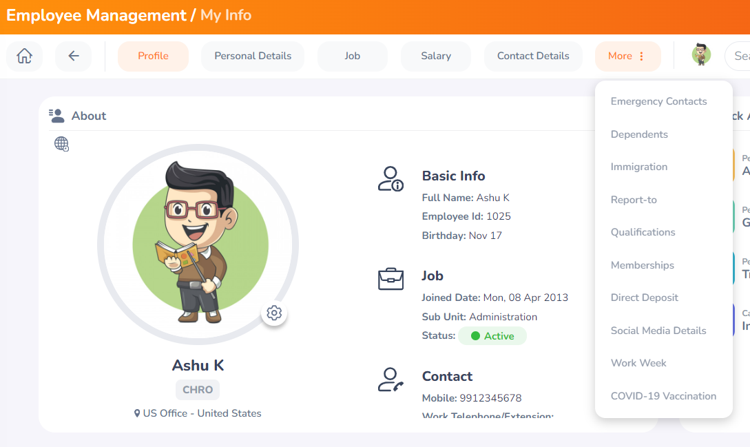

**Initially no records found since we have not added any dependents yet :**

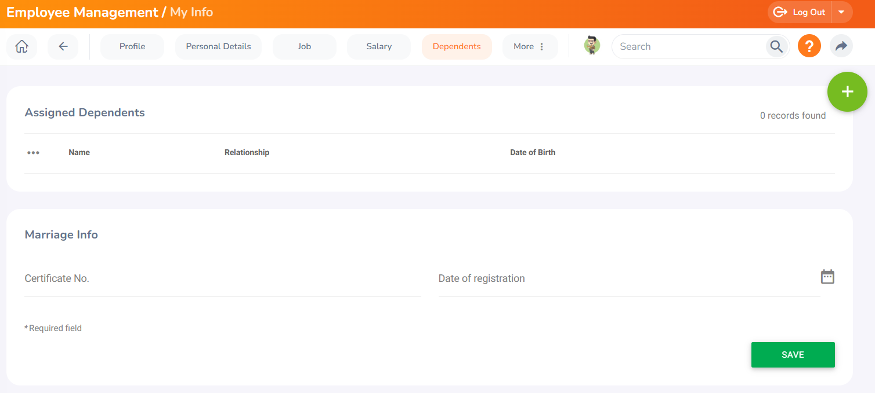

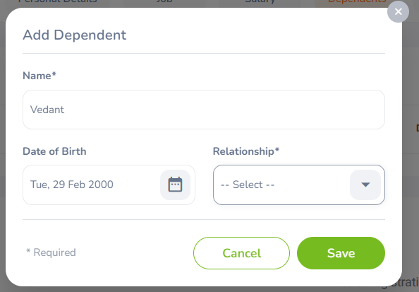

**After this We are unable to open relationship dropdown after clicking : This issue has to be highlighted :**

**TC23, TC24 and TC25 are blocked due to this issue since we are unable to add dependents.**